***What’s the deal with WAVES?***

Waves can be classified by _____________ they move through or by ______________ energy moves through them.

There are two classifications for waves based on what they move ___________________:

* ________________________ Waves
* ________________________ Waves

Mechanical waves are waves that can ____________ move through a _________________ (through ________________).

**Examples of mechanical WAVES?**

_________ waves earthquake/________________ waves

_________waves waves that travel down a rope or spring

Electromagnetic wavesare waves that can travel through matter or __________________ space where matter is not present.

**Examples of electromagnetic WAVES?**

* ____________ waves microwaves
* infrared waves ___________visible light
* _____________ rays X-rays

There are two classifications for waves based on how energy moves through them:

* ____________________/_____________________ Waves
* ____________________ Waves

**What are compressional/ longitudinal WAVES?**

________________ waves in which the particles of matter in the medium vibrate by _______________ together and moving apart *_________________* to the direction *in which the wave travels* are called compressional/longitudinal waves.

The place on the wave that is pushed together is called the __________________ and the place that is moving apart is the _______________.

E**xamples of compressional/ longitudinal waves?**

* _______________ waves
* some waves in a spring
* some _______________ waves (earthquake waves- _________________ waves, to be exact)

**What are transverse WAVES?**

_____________________ waves in which the particles of matter in the medium vibrate by moving ___________ and __________ and perpendicular (at ___________ angles) to the *direction the wave travels* are called transverse waves.

The ______________ point of a transverse wave is the _________ and the ______________ point is called a _______________.

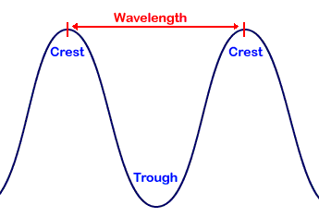

**What is sound?**

* A form of __________________ made by ___________________________.
* When an object vibrates it causes the air particles around it to _______________.   
  These particles bump into particles close to them and this ______________________ until they run out of energy.

**What makes Sound?**

1. _____________________: back and forth motion
2. There can not be _________________________ if there is not any vibration
3. Most vibrations are too ________________________ for you to see.
4. Vibrations require _________________—sound is a form of _____________________.

**How does sound travel?**

* Sound travels through all forms of ________________— **gases, liquids and solid**.  
  These are called the **__________________________**.
* Sound **______________________** travel through a **_____________________________.**
* Sound passes through the medium as **longitudinal or ______________________________________waves.**

**How fast does sound travel?**

**Gas**: sound travels easily through gases. It travels about ____________________ feet per second through air. (That’s how fast it travels when you talk!)

**Liquids**: Sound travels through water about _________________ feet per second. (Think of what ripples look like in the water and how they spread.)

**Solids:** Sound travels through a solid like wood at a rate of ____________________ feet per second. Sound travels fastest through solids!

Sound cannot travel through a __________________ (a space that is “empty” of matter).

**Sound Waves have 3 common features:**

a. Have a set ___________________________

b. Vibrate at different speeds

--______________________________: the number of complete wavelengths, or times an object ____________________________ per second.

c. Carry Energy

--________________________________ is the amount of energy a wave has

--high amplitude sound is made by objects with great vibrating motion

**Pitch**

How ________________ or ________________ a sound is

The higher the pitch the more “__________________________” together the waves are

The higher the __________________ the higher the _____________________________

The lower the ___________________ the lower the _____________________________

* When the vibrations are ______________ you hear a **________________** **pitch**.
* When they’re ___________________, you hear a **___________________ pitch.**

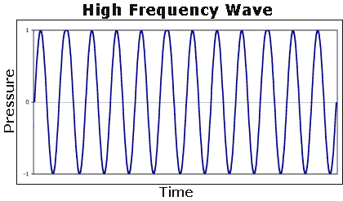 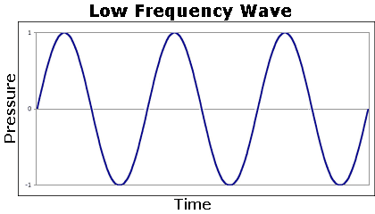

**How else can we change sound?**

* We can make it __________________ or softer by changing the **__________________** of the height of the wave.
* The _________________ the amplitude, the __________________ the sound. The ________________ the amplitude the ____________________ the sound.

**Sound Reflection and Absorption**

Reflected sound is called an ___________________.

The vibrations are __________________________________ back to you.

Soft, air-filled objects __________________________ sound.

When sound is absorbed, you do not hear it because it is not ___________________ back to you.

**Doppler Effect**

* Change in __________________ of a wave due to relative motion between source and observer.
* A sound wave frequency change is noticed as a change in ________________.
* You hear the _______________ pitch of the siren of an ___________________ ambulance and notice that the pitch ___________________ suddenly as the ambulance ___________________ you. This is an example of the ______________ ____________.

