Name ____________________________________ Bell ____ Date _____________

Transverse Waves Worksheet

Amplitude Wavelength
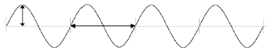

Define the following vocabulary terms:

Amplitude-

Wavelength-

Frequency-

Wave speed= (wavelength) X (frequency)

Measuring Practice:

A camera takes a picture of a wave in a string for one full second. You can use a ruler to measure in centimeters. For each wave answer the following questions and measure parts of the wave.

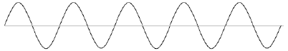
Wave 1

- How many full wavelengths are there in this wave? _______________________
- Measure one Wavelength: ______ cm 3. Measure the Amplitude: ______ cm
4. If this picture was taken over one second, what is the frequency of the wave? _____ Hz
5. You measured the wavelength and found the frequency of the wave. Use the two measurements to calculate the speed of the wave in centimeters per second.

__________ cm/s
Wave 2
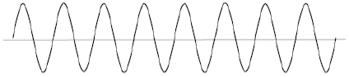

- How many full wavelengths are there in this wave? _______________________
- Measure one Wavelength: ______ cm 3. Measure the Amplitude: ______ cm
4. If this picture was taken over one second, what is the frequency of the wave? _____ Hz
5. You measured the wavelength and found the frequency of the wave. Use the two measurements to calculate the speed of the wave in centimeters per second.

__________ cm/s

Wave 3
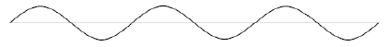

- How many full wavelengths are there in this wave? _______________________
- Measure one Wavelength: ______ cm 3. Measure the Amplitude: ______ cm
4. If this picture was taken over one second, what is the frequency of the wave? _____ Hz
5. You measured the wavelength and found the frequency of the wave. Use the two measurements to calculate the speed of the wave in centimeters per second.

__________ cm/s

Name ____________________________________ Bell ____ Date _____________

Longitudinal Waves Worksheet

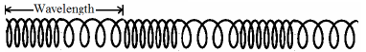

Define the following vocabulary terms:

Period-

Compression-

Rarefaction-

Wave speed= (wavelength) X (frequency)

Frequency and Period are inversely related Frequency= 1/period and Period= 1/frequency

Measuring Practice:

A camera takes a picture of a wave in a string for one full second. You can use a ruler to measure in centimeters. For each wave answer the following questions and measure parts of the wave.

Wave 1

- How many full wavelengths are there in this wave? _______________________
- Measure one Wavelength: ______ cm
3. If this picture was taken over one second, what is the frequency of the wave? _____ Hz
4. If you were to time how long it takes one complete wavelength to pass you by, you have

measured the _____________.

5. Using the frequency you found in question 3, what is the period of the wave? __________

Wave 2

- How many full wavelengths are there in this wave? _______________________
- Measure one Wavelength: ______ cm
3. If this picture was taken over one second, what is the frequency of the wave? _____ Hz
4. If you were to time how long it takes one complete wavelength to pass you by, you have

measured the _____________.

5. Using the frequency you found in question 3, what is the period of the wave? __________

Wave 3

- How many full wavelengths are there in this wave? _______________________
- Measure one Wavelength: ______ cm
3. If this picture was taken over one second, what is the frequency of the wave? _____ Hz
4. If you were to time how long it takes one complete wavelength to pass you by, you have

measured the _____________.

5. Using the frequency you found in question 3, what is the period of the wave? __________

