Name: ___________________________________ Period: __________ Date: ________________

Sound WebQuest

Part 1: Vocabulary Go to this website: http://www.fi.edu/fellows/fellow2/apr99/soundvib.html

Define the following words in terms of sound waves.

Amplitude: __________________________________________________________________
Compression: _________________________________________________________________
Rarefaction: _________________________________________________________________
Frequency: __________________________________________________________________
Wavelength: _________________________________________________________________
Pitch: _____________________________________________________________________

Part 2: Sound Basics Go to this website: http://www.philtulga.com/MSSActivities.html

1. What is the unit for volume or loudness: _______________________ How is it abbreviated: ________

2. According to this website, how fast can sound travel? ______________________________________

3. Will sound travel faster at 58°C or 88°C? ________________

Explain why this happens?________________________________________________________ ___________________________________________________________________________
4. Based on what you learned from question #3, answer the following questions about the speed of sound by circling the medium in which you think sound would travel faster through:

a. Water or air b. solid or air c. water or solid

d. Explain why you think these are going to move faster? _________________________________ ___________________________________________________________________________
5. Objects which vibrate faster produce a higher _________________, and objects which vibrate more slowly produce a lower _________________.
6. If you make a musical instrument shorter, will it have a higher or lower frequency?

7. Draw a tuning fork in the space below. Then draw a diagram similar to the one on the website that’s shows how many waves will pass in 1 second if it has a frequency of 10 Hz.

Go to this website: http://www.school-for-champions.com/science/sound.htm

8. Does sound travel in a vacuum? _________ Why? ________________________________________

9. Under the heading “Characteristics of Sound,” copy the equation for the velocity of sound.

____________________________________________________________________

10. Take the mini-quiz at the bottom of the page. Put the correct answers here.

1)____________ 2) ______________ 3) ____________

Part 3: Vibrations and Waves

Watch the video and answer the following questions.
Bill Nye: Sound Go to: https://www.youtube.com/watch?v=ACeUO4ufx2I
- What do the sound waves make air molecules do? _________________________________________
- How are the air hockey pucks like air molecules? __________________________________________
- Describe what happens to the air hockey pucks when they are hit. _____________________________
- How is that similar a sound wave? _____________________________________________________
Mr. Science Man Go to: https://www.youtube.com/watch?v=_vYYqRVi8vY#aid=P9jgY1xQLSw
- What does the amount of compression in a wave tell you about the sound? _______________________
- Sound waves are ______________ waves. They compress in the _______ direction as they travel.
- How do the vibrations of sound travel? (Hint: it has something to do with air) _____________________
_____________________________________________________________________________
- How can the TONE of a sound wave be changed? __________________________________________
- Higher frequencies mean ______________ pitched sounds.
- How is a sonic boom generated? ______________________________________________________

Part 4: Do You Hear What I Hear?

1. What range of sounds can the human ear hear? ____________________________________________
2. What are three animals that can hear higher pitched sounds than humans? ________________________
3. What are three animals that can hear lower pitched sounds than humans? ________________________

Part 5: The Doppler Effect

Watch the following videos and answer the questions.

Go to: https://www.youtube.com/watch?v=JX_A99Bq9AI. Then, Go to: https://www.youtube.com/watch?v=h4OnBYrbCjY

- The pitch gets ________ as the object approaches and ________ as it moves away.
- When something that is making a sound moves, what happens the waves in front of it and behind it? ____________________________________________________________________________
- When something that is making a sound is moving toward you, the sound is a __________ frequency and when it is moving away from you, the sound is a ____________ frequency.
- High frequency = high or low pitch? Low frequency = high or low pitch?
- Describe the Doppler Effect in your own words: ___________________________________________
_____________________________________________________________________________

Part 5: The Ear Go to the website: http://www.enchantedlearning.com/subjects/anatomy/ear/

Complete the following diagram of the ear. Then write what each part of the ear does in the space provided.
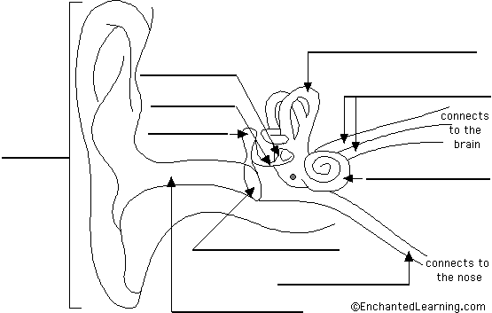
Anvil: ____________________________
_________________________________
_________________________________
Cochlea: _________________________
_________________________________
_________________________________
Eardrum: (also called the tympanic membrane) _________________________________ _________________________________
Eustachian tube: __________________________________________________________________
Hammer: (also called the malleus) ______________________________________________________
Nerves: _________________________________________________________________________
Outer ear canal: _________________________________________________________________
Pinna: (also called the auricle) _________________________________________________________
Semicircular canals: _______________________________________________________________
Stirrup: (also called the stapes) ________________________________________________________

Go to: http://faculty.washington.edu/chudler/java/revear.html
Take the following quiz about sound and the ear with your group. Record your scores on the lines provided.
Quiz 1 Score: _________ http://faculty.washington.edu/chudler/java/revear.html

