Changing States of Matter Notes

The three states of matter are solids, liquids, and gasses.

SOLIDS | LIQUIDS | GASES
Keeps a fixed volume  Keeps a fixed shape | Keeps a fixed volume  Takes shape of container | Takes volume and shape of container
Not easily compressed  Little free space between particles | Not easily compressed  Little free space between particles | Easily compressed  Lots of free space between particles
Does not flow easily  Rigid - particles jiggle/vibrate but do not slide past one another  Vibrate | Flows easily  Particles can move/slide past one another  Vibrate and slide | Flows easily  Particles can move past one another  Move at high speeds

Some consider plasma a fourth state of matter.

Plasma: A plasma is when the gas is heated to a very high temperature. Some of the electrons around the atoms are stripped away and the particles become positively charged ions! Some examples where plasma is found include stars, plasma TVs, fluorescent lights, lightening, and the sun.

When a state of matter gains or loses heat it undergoes a change.

CHANGE | FROM | TO | HEAT | EXAMPLES
Melting
Freezing
Evaporation/ Vaporization
Condensation
Sublimation
Deposition

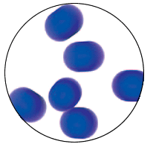
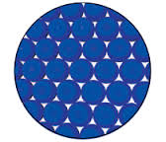
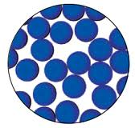
Label each state of matter and each phase change represented by an arrow.

Heating Curve of Water

