Name____________ Heat Transfer Stations
Bell______________

Station 1: Boiling water/Craisins
1.Identify the type of heat transfer-Circle one : Conduction, Convection, Radiation
2.Why did you choose that type of heat transfer?

3. Which direction is the heat moving? (Draw a diagram in the space provided)

4. Is the heat movement happening in a solid, liquid, or gas?

Station 2: Sand/ heat lamp
5. Identify the type of heat transfer-Circle one : Conduction, Convection, Radiation
6.Why did you choose that type of heat transfer?

7.Which direction is the heat moving? (Draw a diagram in the space provided)

8. Is the heat movement happening in a solid, liquid, or gas?

Station 3: Ice cubes
9. Identify the type of heat transfer-Circle one : Conduction, Convection, Radiation
10. Why did you choose that type of heat transfer?

11. Which direction is the heat moving? (Draw a diagram in the space provided)

12. Is the heat movement happening in a solid, liquid, or gas?

Station 4: Spiral
13. Identify the type of heat transfer-Circle one : Conduction, Convection, Radiation
14.Why did you choose that type of heat transfer?

15.Which direction is the heat moving? (Draw a diagram in the space provided)

16. Is the heat movement happening in a solid, liquid, or gas?

Station 5: Heat fan

17. Identify the type of heat transfer-Circle one : Conduction, Convection, Radiation
18..Why did you choose that type of heat transfer?

19.Which direction is the heat moving? (Draw a diagram in the space provided)

20. Is the heat movement happening in a solid, liquid, or gas?

Demonstration: Hotplate popcorn Vs. Microwave Popcorn
Compare and contrast the differences and similarities between the each type of popcorn pops using the Venn diagram. (Be sure to mention what phase of matter and what type of heat transfer is present.)

Microwave Both Hotplate
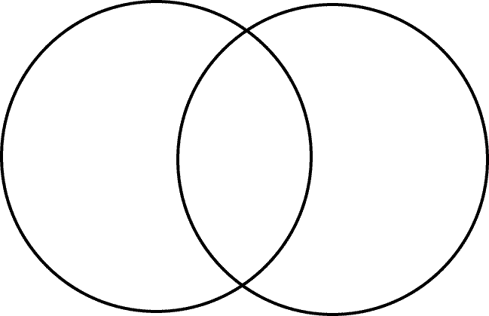
22. (A.)Describe the third way we could prepare popcorn using another type of heat transfer.(B.) Which type of heat transfer do you think is used in the mass production of popcorn? Why?

